How input arguments are parsed in bash shell script
Generally we pass arguments to a script using this syntax
~]# ./eg_1.sh first second third fourth
Now to store all these arguments inside the script in a single variable we can use "$@"
But to store these arguments in individual variable, you can assign the values based on the numerical position of the input argument. You can check this sample script where I am storing upto 4 arguments in individual variables. You can use any names for the variable, I have used these just for better understanding. Here any argument after 4th place will be ignored.
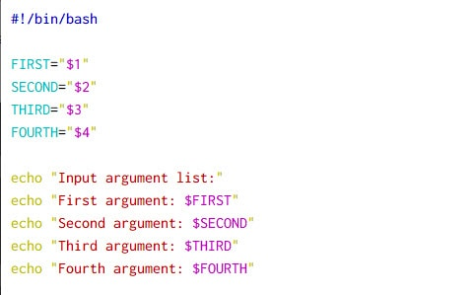

Let,s execute this script:
~]# ./eg_1.sh first second third fourth
Input argument list:
First argument: first
Second argument: second
Third argument: third
Fourth argument: fourth
So as expected the script has successfully stored the input arguments and printed them on the screen

Method 1: Parse input arguments with if condition and while loop
In this example we will use if condition to parse the input arguments and perform respective action. Here I have written a small script which is expected to collect following input arguments
Advertisement
- -h or --help should print the usage function
- -r [RPM] or --rpm [RPM] will just print the provided rpm name on the console
- -s [VAL] or --sleep [VAL] will just [print the sleep value on the console
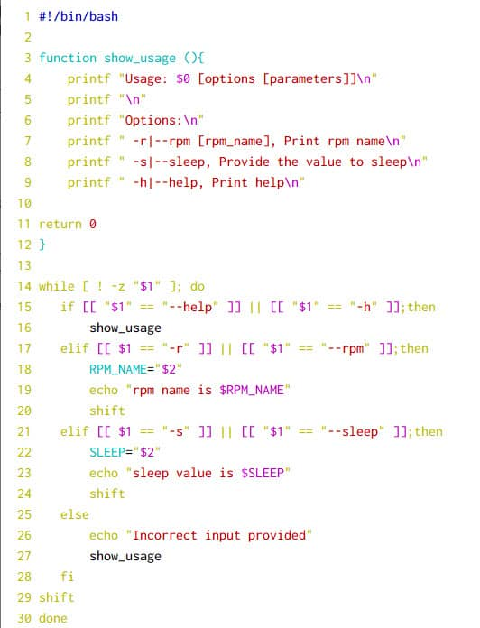

Let us understand this script:
- Line 3 to Line 12 are my usage function which should be clear enough.
- Line 14 I am using a while loop if [ ! -z "$1" ] condition which will make sure that our if condition will continue to be checked until there are no further input arguments. This is a more robust solution rather than assigning individual arguments to a variable as here we don't have to worry about the order of input arguments.
- Line 15 will check for --help or -h for the first input argument and if found it will print the usage function content from Line 16
- Line 17 will check for -r or --rpm in the provided first argument and if found store the second input argument with $2 into RPM_NAME variable at Line 18
- Line 19 will print the content of $RPM_NAME variable
- Line 20 is used to shift the position so that we don't have to use $3 next time as that may be confusing and alot of things can go wrong so shift is very important when dealing with input arguments
- Line 21 will check for -s or --sleep in the first input argument and if found the second input argument will be stored in SLEEP variable using $2 argument in Line 22
- Line 23 will print the SLEEP value collected at Line 22
- Line 24 is again important as we will perform a shift operation
- Line 25 to 28 will be executed if no matching input arguments found by printing the usage function
- Line 29 again contains shift to make sure the script doesn't end up in an infinite loop
- Line 30 will end the while loop

You can execute the script by shuffling the order of input arguments and it should still work. Although I am not a big fan of this method as it is very messy and I would prefer case over if condition if the number of input arguments is more than 3.
~]# ./eg_1.sh -r kernel -s 10
rpm name is kernel
sleep value is 10

~]# ./eg_1.sh -s 10 -r kernel
sleep value is 10
rpm name is kernel

When should we use "shift" when working with input arguments
- You may get confused as in when should you use shift when working with input arguments.
- If your input arguments don't expect a value for the respective argument then you can ignore shift, as you can see I didn't used shift for -h or --help in the above script
- If you are using a loop to parse through your argument then you have to use shift depending upon your requirement. If your input arguments don't expect a value then a shift is required near the end of the loop only.
- Consider a scenario wherein you have to collect ~10 input arguments and some of them may expect input value for respective arguments so it would be very hard to manage with $1, $2 .. to collect the input arguments
- So we use while loop with shift operation so that the loop will iterate over the available input arguments
- With while loop we will always deal with $1 and $2 for the input arg and arg's value so the solution is cleaner
- Once you have the value you can perform shift so we again start from $1
- If you have a requirement to only collect 2-3 input arguments you can avoid shift if it feels too complicated for you.

Method 2: Parse input arguments with case statement and while loop
In this example we will use case statement with while loop to check for input arguments. As you can see the script looks much cleaner compared to the one with if condition:
while [ ! -z "$1" ];do
case "$1" in
-h|--help)
show_usage
;;
-r|--rpm)
shift
RPM_NAME="$1"
echo "rpm name is $RPM_NAME"
;;
-s|--sleep)
shift
SLEEP="$1"
echo "sleep value is $SLEEP"
;;
*)
echo "Incorrect input provided"
show_usage
esac
shift
done
I don't think I need to again explain this part of the script line by line. Here I have switched the position of shift so now if $1 matches the condition such as -r or --rpm then I do the shift so now second argument has become the first for me so I store the first argument into RPM_NAME and print the same

We can execute the script and verify in any possible order:
~]# ./eg_1.sh -s 10 -r kernel
sleep value is 10
rpm name is kernel

~]# ./eg_1.sh -r kernel -s 10
rpm name is kernel
sleep value is 10

Handling exceptions and errors with bash script arguments

Scenario 1: Missing value for input argument
In all the examples above we also worked on success use case. But what if you were expecting an input argument with a value but the user forgot to pass a value? In such case your entire loop can break. Let's use the above case statement to demonstrate this:
~]# ./eg_1.sh -r -s 10
rpm name is -s
Incorrect input provided
Usage: ./eg_1.sh [options [parameters]]

Options:
-r|--rpm [rpm_name], Print rpm name
-s|--sleep, Provide the value to sleep
-h|--help, Print help
As expected I did not gave a value for -r so -s was considered as the rpm name and then 10 was considered as an input argument. Since we have not defined 10 as a supported input arg, the script failed and printed the usage function.
So it is very important that we handle such error scenarios. Now the handling may vary from case to case. For example if you are only expecting an integer as a value for some input argument then you can add that check, let me show you some examples:
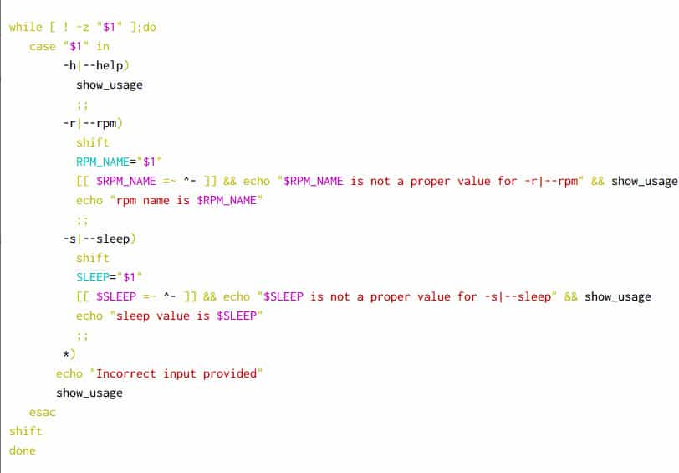
Advertisement
In this script I have added below addition check:
[[ $RPM_NAME =~ ^- ]] && echo "$RPM_NAME is not a proper value for -r|--rpm" && show_usage
[[ $SLEEP =~ ^- ]] && echo "$SLEEP is not a proper value for -s|--sleep" && show_usage
So we know that all our input arguments start with hyphen so if the value of input argument starts with hyphen then it means that a value was not provided.
Let's test this script, and it works perfectly this time:
~]# ./eg_1.sh -r -s 10
-s is not a proper value for -r|--rpm
Usage: ./eg_1.sh [options [parameters]]

Options:
-r|--rpm [rpm_name], Print rpm name
-s|--sleep, Provide the value to sleep
-h|--help, Print help

Scenario 2: Count input arguments list
Another possible scenario of failure would be where we expect only 2 input arguments but the user gives more then 2 input arguments, so we should add a check for supported arguments:
Here we will count the list of minimum supported arguments and if it is greater than 3 then print a message with usage section and exit:
if [ $# -gt 3 ];then
echo "Only 3 input arguments supported"
show_usage
exit 1
fi

while [ ! -z "$1" ];do
case "$1" in
-h|--help)
show_usage
;;
<output trimmed>
Let's verify our script:
# ./eg_1.sh -r -s 10 -a
Only 3 input arguments supported
Usage: ./eg_1.sh [options [parameters]]

Options:
-r|--rpm [rpm_name], Print rpm name
-s|--sleep, Provide the value to sleep
-h|--help, Print help

Scenario 3: When script is executed without any argument
Similarly what if the user executes the script without any input argument? In such case also we should exit by showing the usage section:
if [[ $# -gt 3 ]] || [[ $# -eq 0 ]];then
echo "Either 0 or more than 3 input arguments provided which is not supported"
show_usage
exit 1
fi

while [ ! -z "$1" ];do
case "$1" in
-h|--help)
show_usage
;;
<output trimmed>
So I have added one more check in the same if condition, let's verify this script:
~]# ./eg_1.sh
Either 0 or more than 3 input arguments provided which is not supported
Usage: ./eg_1.sh [options [parameters]]

Options:
-r|--rpm [rpm_name], Print rpm name
-s|--sleep, Provide the value to sleep
-h|--help, Print help
Similarly you can add multiple checks based on your requirement

What is a function in bash?
- The definition of function will not change only for bash and will remain same across all programming languages
- Although there may be few functional changes so we will only talk about shell function
- A function can be considered as command which internally is a combination of multiple commands, values, positional parameters etc
- So we club all these values, commands together into a single function so it becomes easier for us to use the same set of commands together
Confused? Why do I need to use function?
Let us take a simple example. We have to perform below set of tasks
1. Create 100 Users
2. Assign different password to individual users
3. Make sure the user changes password on it's first login
4. Assign separate home directory for the user
- We have a bunch of tasks to be done
- We can go ahead and write individual commands for each tasks, OR
- We define a function and put all the commands, variables into this one single function (or you may create more than one function)
- Using this single function we would be able to perform all the tasks
- Still wondering why we need a function for this, why not just call it in plain script?
- Yes TRUE, we can call these commands in plain script but imagine you have 10000+ lines of code, wouldn't it be easier if we had it arranged in separate function where each function does it's own job
For example:
1. One function to create users and assign passwords
2. Another one to handle it's home directories
3. Last one to make sure user changes it's password after first login
This is all very theoretical, I will show you some real time practical examples to help you understand better.

How do we define bash function?
The basic syntax to define a function in shell script would be
<function_name> [()] {
compound-command
}
OR you can also use
Advertisement
function <function_name> [()] {

compound-command
}

What is the difference between these function syntax?
You must be wondering which of these syntax should I choose to write my first function?
The one liner answer is that "you can use any of the above syntax" but I would recommend to also read below:
The detailed answer is:
- function keyword is originally used with KSH shell
- Later bash shell also introduced support for function keyword
- There is no reason to use parenthesis while defining a function, although bash man page does mentions about using parenthesis with function
- But we never know as the support for () may be removed in future bash version
- So the recommended syntax for shell script with global support would be
function <function_name> {

compound-command
[redirection]
}
To learn more about the different syntax and their behaviour you can read more at Unix Stack Exchange

Understanding the function syntax
- You define your bash function name by replacing function_name in the syntax
- There is no such restriction while choosing for function name. It can contain solely letters, numbers, and underscores, and beginning with a letter or underscore.
- The block between curly braces {} is the main function block where you will place your commands
- Unlike some of the programming language, there is no such restriction to put semi-colon ";" after every command
- But if you plan to write two different command in same line then you must use semi-colon ";", for example, command 1; command 2
# cat /tmp/shell_script.sh
1 #!/bin/bash
2
3 function print_name {
4 echo "My name is Deepak"
5 }
6
7 # Call your function
8 print_name
- In Line 3 we have defined our function print_name and starting of our function block with OPEN curly brace {
- Line 4 contains the command to be executed inside the function body
- Line 5 contains the CLOSE curly braces }
- On Line 8 we will call our function by just writing the function name. No special handling needed
This function will only execute echo "My name is Deepak" on the terminal screen, the output from this script:
# /tmp/shell_script.sh
My name is Deepak
You must provide executable permission to this script chmod u+x /tmp/shell_script.sh

Local and Global variables
Now since you know about bash function, you should be really careful the way you would define your VARIABLES

Why do I need VARIABLES in script?
- It is strongly recommended to use VARIABLES as much as possible while writing any script
- As it avoids writing hard code and repetitive values
- Let's assume you have to use a file from /tmp/dir1/ file at different location in your script which you define manually without using variables
- Now few days later you realise that the path needs to be changed to /tmp/dir2/file, now imagine doing this task at all the places within the script and if you miss to update even at one place then the script would fail
- So we create one variable with name name such as FILE_PATH=/tmp/dir1/file and I will use this variable $FILE_PATH across the script. Now even if you have to change the path you just update this one variable and you are good to do go..
It is important you understand the difference between Local and Global Variable. Let us look at this sample script:
Advertisement
1 #!/bin/bash
2
3 SOME_VAR="GLOBAL"
4
5 function print_name {
6 SOME_VAR="LOCAL"
7 echo "My name is Deepak"
8 }
9
10 # Check the value of VARIABLE before we call the function
11 echo "Before calling function, SOME_VAR: $SOME_VAR"
12
13 # Call your function
14 print_name
15
16 # Check the value of VARIABLE after we call the function
17 echo "After calling function, SOME_VAR: $SOME_VAR"
The output from this script:
Before calling function, SOME_VAR: GLOBAL
My name is Deepak
After calling function, SOME_VAR: LOCAL
What do we understand?
- Line 3 we have defined SOME_VAR which will be our global variable
- Line 6 we have re-defined SOME_VAR inside the function print_name block, since this is limited to the function block, it will be considered as local variable
- Line 11 we check the value of SOME_VAR. At this stage since the function print_name is not executed yet, so the content of SOME_VAR would be "GLOBAL"
- Line 14 we execute the function which would also execute the SOME_VAR variable within the function block
- In Line 17 we re-check the content of SOME_VAR and now it will be changed to LOCAL because the function print_name has now made this as global variable
- So after Line 14, any command or function if tries to use SOME_VAR then the value of this variable would be LOCAL

Call bash function with arguments
- We also have an option to pass input arguments to the bash function.
- Why would you need that you ask?
- Imagine you are trying to write a function to compare two integers but these integers will be provided by end user as command line argument
- So how will function access these integer values for comparison?
- We can pass them as an input to the script which will further be passed to the function
- To pass values within the script you should pass the values just next to the function separated by single white space character
The syntax to for this would be:
function_name "[arg1]" "[arg2]" "[arg3]" ..
To store this you should also collect these input values within your function. You can use any variable name, I have used ARG1, ARG2, ARG3 here..
function function_name {
ARG1="$1"
ARG2="$2"
ARG3="$3"

COMMANDS
}
Or you can pass all the input values into single array/variable
function_name string1 string2 string3
To store this you should also collect these input values within your function into a single array/variable
function function_name {
ARG="$@"

COMMANDS
}

Pass and store input arguments into different Variables
In this sample shell script, I have passed three input strings to my bash function pass_arg
And I am storing these three strings into three different variables and then printing the content of this variable. It is recommended to put all the input values into inverted commas " " assuming anyone of these input values contains white space.
#!/bin/bash

function pass_arg {
# Collect Input Values
ARG1="$1"
ARG2="$2"
ARG3="$3"

# Print the variable content
echo "First: $ARG1"
echo "Second: $ARG2"
echo "Third: $ARG3"
}
# Executing the function
pass_arg "argument1" "argument2" "argument3"
From the output from this script we see the script was successfully able to store all the three input values into three different variables:
First: argument1
Second: argument2
Third: argument3

Pass and store input arguments into single Variable
In the next sample shell script, I will store all the input values into single VARIABLE. In this case you should not use inverted commas " " for individual strings or else only the first value "string1" would be considered by the bash function. Either you put the entire list of strings under inverted commas like "string1 string2 string3" or you can just pass the entire list without inverted commas to your function as I have done in this script.
function pass_arg {
# Collect Input Values
ARG="$@"

# Print the variable content
echo "Input argument list: $ARG"
echo "Variable Length: ${#ARG[@]}"

}

# Call your function
pass_arg string1 string2 string3
From the output from this scrip we see the function has successfully parsed the input list of values and stored into single variable. I have also printed the variable length so that we know the script has not considered it as an array.
Input argument list: string1 string2 string3
Variable Length: 1
Even though there are 3 strings each separated by white space, bash considers it as a VARIABLE

Pass and store input arguments into Array
To store the input values as ARRAY you must make sure of two things
1. Do not pass input values under semi colon
2. Store the input values within bash function inside parenthesis
I would recommend to also read How to split string into array using 4 simple methods in bash
#!/bin/bash
function pass_arg {
# Collect Input Argument and convert the VAR to ARRAY using parenthesis
ARG=("$@")

# Print the array content
echo "Input argument list: $ARG"
echo "Variable Length: ${#ARG[@]}"

}

# Call your function
pass_arg string1 string2 string3
The output from this script:
Input argument list: string1 string2 string3
Variable Length: 3
Now bash considers ARG as ARRAY as it could identify three different strings from ARG from the length syntax.

Let me also give you one practical example on this:
In shell scripts we normally have a lot of echo statement and most of the time we have to also store these echo statements to some log files
So we create a function which will echo statement to the screen and also send the same message to a log file so that we don't have to repeat the same command twice:
#!/bin/bash

# Define Log file variable
LOGFILE=/var/log/myapp.log

function log_content {

# print on output
echo "$*"

# store the logs
echo "$*" >> $LOFILE

}

# Execute the function
log_content "Starting the process"
We can also enhance the function to print date and time along with hostname while storing the logs in the log file just like the format as we have messages in /var/log/messages
#!/bin/bash

# Define Log file variable
LOGFILE=/var/log/myapp.log

function log_content {

# print on output
echo "$*"

# store the logs with timestamp
echo "`date +"%b %e %T"` `hostname` "$*" >> LOGFILE

}

# Execute the function
log_content "Starting the process"
So now we have a function which taken input values and then use it to print the info on screen and also store it in log file.

Collect command line arguments from end user and pass it to function
- You can also collect input from end user as command line argument and then pass it as an input to the function
- We are storing the input values into single variable i.e. ARG
- Then we are passing this variable to the function
- Next inside the function we need to again collect and store it in a different variable INPUT_ARG for further processing
- Now you can use INPUT_ARG within your function
#!/bin/bash

ARG="$*"

function pass_arg {

INPUT_ARG="$1"
echo "Input Argument: $INPUT_ARG"
}

# Call your function
pass_arg "$ARG"
Then we execute the script with an input value as "deepak"
# /tmp/shell_script.sh deepak
Input Argument: deepak
The function has collected the input value, stored it in ARG then this $ARG was passed on to the function. The function read this input and stored it in INPUT_ARG which was later used as $INPUT_ARG.

Use Return Values in Function
- When working with bash functions, you must be familiar with return keyword used inside function
- You cannot use return outside function block
- In laymen terms, return is used as an alternate for exit statement. (Although both are not same)
- The advantage with return is that you can choose to come out of a function without actually coming out of the script.
- If you have already heard of continue, break as I explained in my earlier articles with for and while loop then you may get confuse with return as it may sound familiar
- continue and break are used to come out of the loop conditions only but the additional advantage with return is to pass an exit code also while coming out of the loop
Let us use this in shell script to understand the usage properly:
- Line 3 we have defined a function return_value
- Line 5 we are printing a simple statement on the screen using echo
- Line 6-10 we are check the exit status of echo command
- At Line 7 if the exit status is 0 then return 0 will be called
- If the exit status in non-zero then at Line 9, return 1 would be called
- At Line 13 we have defined another echo statement within the same function block
- NOW the mistake which I have done is that I have also put an echo after the return value. This section will never be called, so look out for such scenarios.
- Please NOTE If your loop triggers return value then the remaining part of the function will not be executed
- Line 18 we execute the function and again at Line 19 we check the exist status of the function
- Line 21 we print a statement with the exit code of the function. This exit code should match the return code from within the function block
1 #!/bin/bash
2
3 function return_values {
4
5 echo "We do something"
6 if [ $? == 0 ];then
7 return 0
8 else
9 return 1
10 fi
11
12 # This will not be called as the function will exit at return stage above
13 echo "Good Day"
14
15 }
16
17 # Call your function
18 return_values
19 exit_status=$?
20
21 echo "The exit status of function is: $exit_status"
Now we execute the script, the exit code of our script is same as function's return value
We do something
The exit status of function is: 0
We know we did some mistakes in the above script, The proper way to write above script would be:
#!/bin/bash

function return_values {

echo "We do something"
if [ $? != 0 ];then
return 1
fi

# This will not be called as the function will exit at return stage above
echo "Good Day"
return 0
}

# Call your function
return_values
exit_status=$?

echo "The exit status of function is: $exit_status"
So now we don't exit at the first command instead we add a negative check. The bash function will exit only if the first echo statement fails or else we will get both the echo statement
The output from this script would be:
We do something
Good Day
The exit status of function is: 0

Sample script with variable containing strings
For example in this script I have a variable myvar with some strings as element
# cat /tmp/split-string.sh
#!/bin/bash

myvar="string1 string2 string3"

echo "My array: $myvar"
echo "Number of elements in the array: ${#myvar[@]}"
Here if I want to iterate over individual element of the myvar variable, it is not possible because this will considered as a variable and not an array.
This we can verify by counting the number of elements in the myvar variable
When we execute the script, we see that number of elements in myvar is 1 even when we have three elements
# /tmp/split-string.sh
My array: string1 string2 string3
Number of elements in the array: 1
To overcome this we convert and split string into array. Now your variable can have strings or integers or some special characters, so depending upon your requirement you can choose different methods to convert string into an array. I will cover some of them with examples:
ALSO READ:
Bash compare strings | Bash regex match | Script Examples

Method 1: Bash split string into array using parenthesis
Normally to define an array we use parenthesis (), so in bash to split string into array we will re-define our variable using open and closed parenthesis
Advertisement
# cat /tmp/split-string.sh
#!/bin/bash

myvar="string1 string2 string3"

# Redefine myvar to myarray using parenthesis
myarray=($myvar)

echo "My array: ${myarray[@]}"
echo "Number of elements in the array: ${#myarray[@]}"
Snippet from my terminal
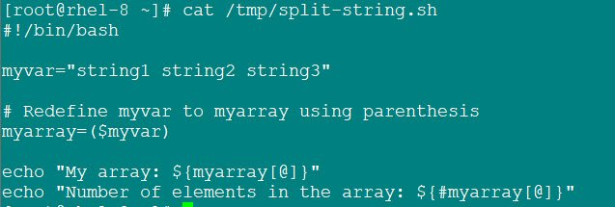Method 1
Next execute the shell script. We see know we have 3 elements in the array
# /tmp/split-string.sh
My array: string1 string2 string3
Number of elements in the array: 3

Method 2: Bash split string into array using read
We can use read -a where each input string is an indexed as an array variable.
the default delimiter is considered as white space so we don't need any extra argument in this example:
# cat /tmp/split-string.sh
#!/bin/bash

myvar="string1 string2 string3"

# Storing as array into myarray
read -a myarray <<< $myvar

echo "My array: ${myarray[@]}"
echo "Number of elements in the array: ${#myarray[@]}"
Snippet from my terminal
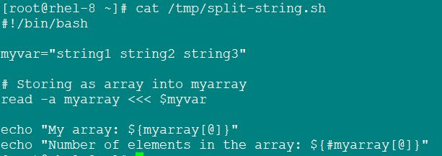Method 2
Execute the script. Now the myarray contains 3 elements so bash split string into array was successful
# /tmp/split-string.sh
My array: string1 string2 string3
Number of elements in the array: 3

Method 3: Bash split string into array using delimiter
We can combine read with IFS (Internal Field Separator) to define a delimiter.
Assuming your variable contains strings separated by comma character instead of white space as we used in above examples
We can provide the delimiter value using IFS and create array from string with spaces
# cat /tmp/split-string.sh
#!/bin/bash

myvar="string1,string2,string3"

# Here comma is our delimiter value
IFS="," read -a myarray <<< $myvar

echo "My array: ${myarray[@]}"
echo "Number of elements in the array: ${#myarray[@]}"
Snippet from my terminal
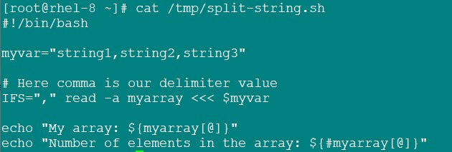Method 3
Execute the shell script, and the variable is successfully converted into array and the strings can be iterated separately
# /tmp/split-string.sh
My array: string1 string2 string3
Number of elements in the array: 3

Advertisement

Method 4: Bash split string into array using tr
tr is a multi purpose tool. We will use this tool to convert comma character into white space and further using it under parenthesis from Method 1 to create array from string with spaces
So you can use this with any other delimiter, although it may not work under all use cases so you should verify this based on your requirement
# cat /tmp/split-string.sh
#!/bin/bash

myvar="string1,string2,string3"

# Change comma (,) to whitespace and add under braces
myarray=(`echo $myvar | tr ',' ' '`)

echo "My array: ${myarray[@]}"
echo "Number of elements in the array: ${#myarray[@]}"
Snippet from my terminal
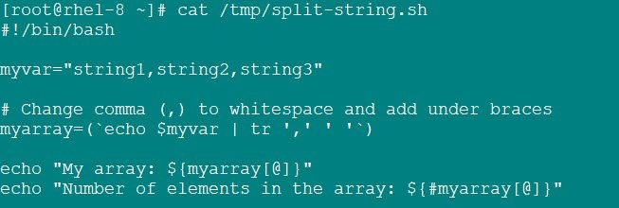Method 4
Execute the shell script
# /tmp/split-string.sh
My array: string1 string2 string3
Number of elements in the array: 3
Some more examples to convert variable into array in bash
Based on your requirement you can choose the preferred method.
For example here I have a variable with newline as delimiter. So here I can use the first method. This will create array from string with spaces
# cat /tmp/split-string.sh
#!/bin/bash

myvar="string1
string2
string3"

myarray=($myvar)

echo "My array: ${myarray[@]}"
echo "Number of elements in the array: ${#myarray[@]}"
Execute the script. You can verify using the number of elements in the array
[root@rhel-8 ~]# /tmp/split-string.sh
My array: string1 string2 string3
Number of elements in the array: 3
We can now iterate through the elements which are part of the array in a loop
# cat /tmp/split-string.sh
#!/bin/bash

myvar="string1
string2
string3"

myarray=($myvar)
echo "My array: ${myarray[@]}"
echo "Number of elements in the array: ${#myarray[@]}"

for (( i=0; i<=${#myarray[@]}; i++ )); do
echo "${myarray[$i]}"
done
Execute the script to verify
# /tmp/split-string.sh
My array: string1 string2 string3
Number of elements in the array: 3
string1
string2
string3

